RAS_PI pinouts:

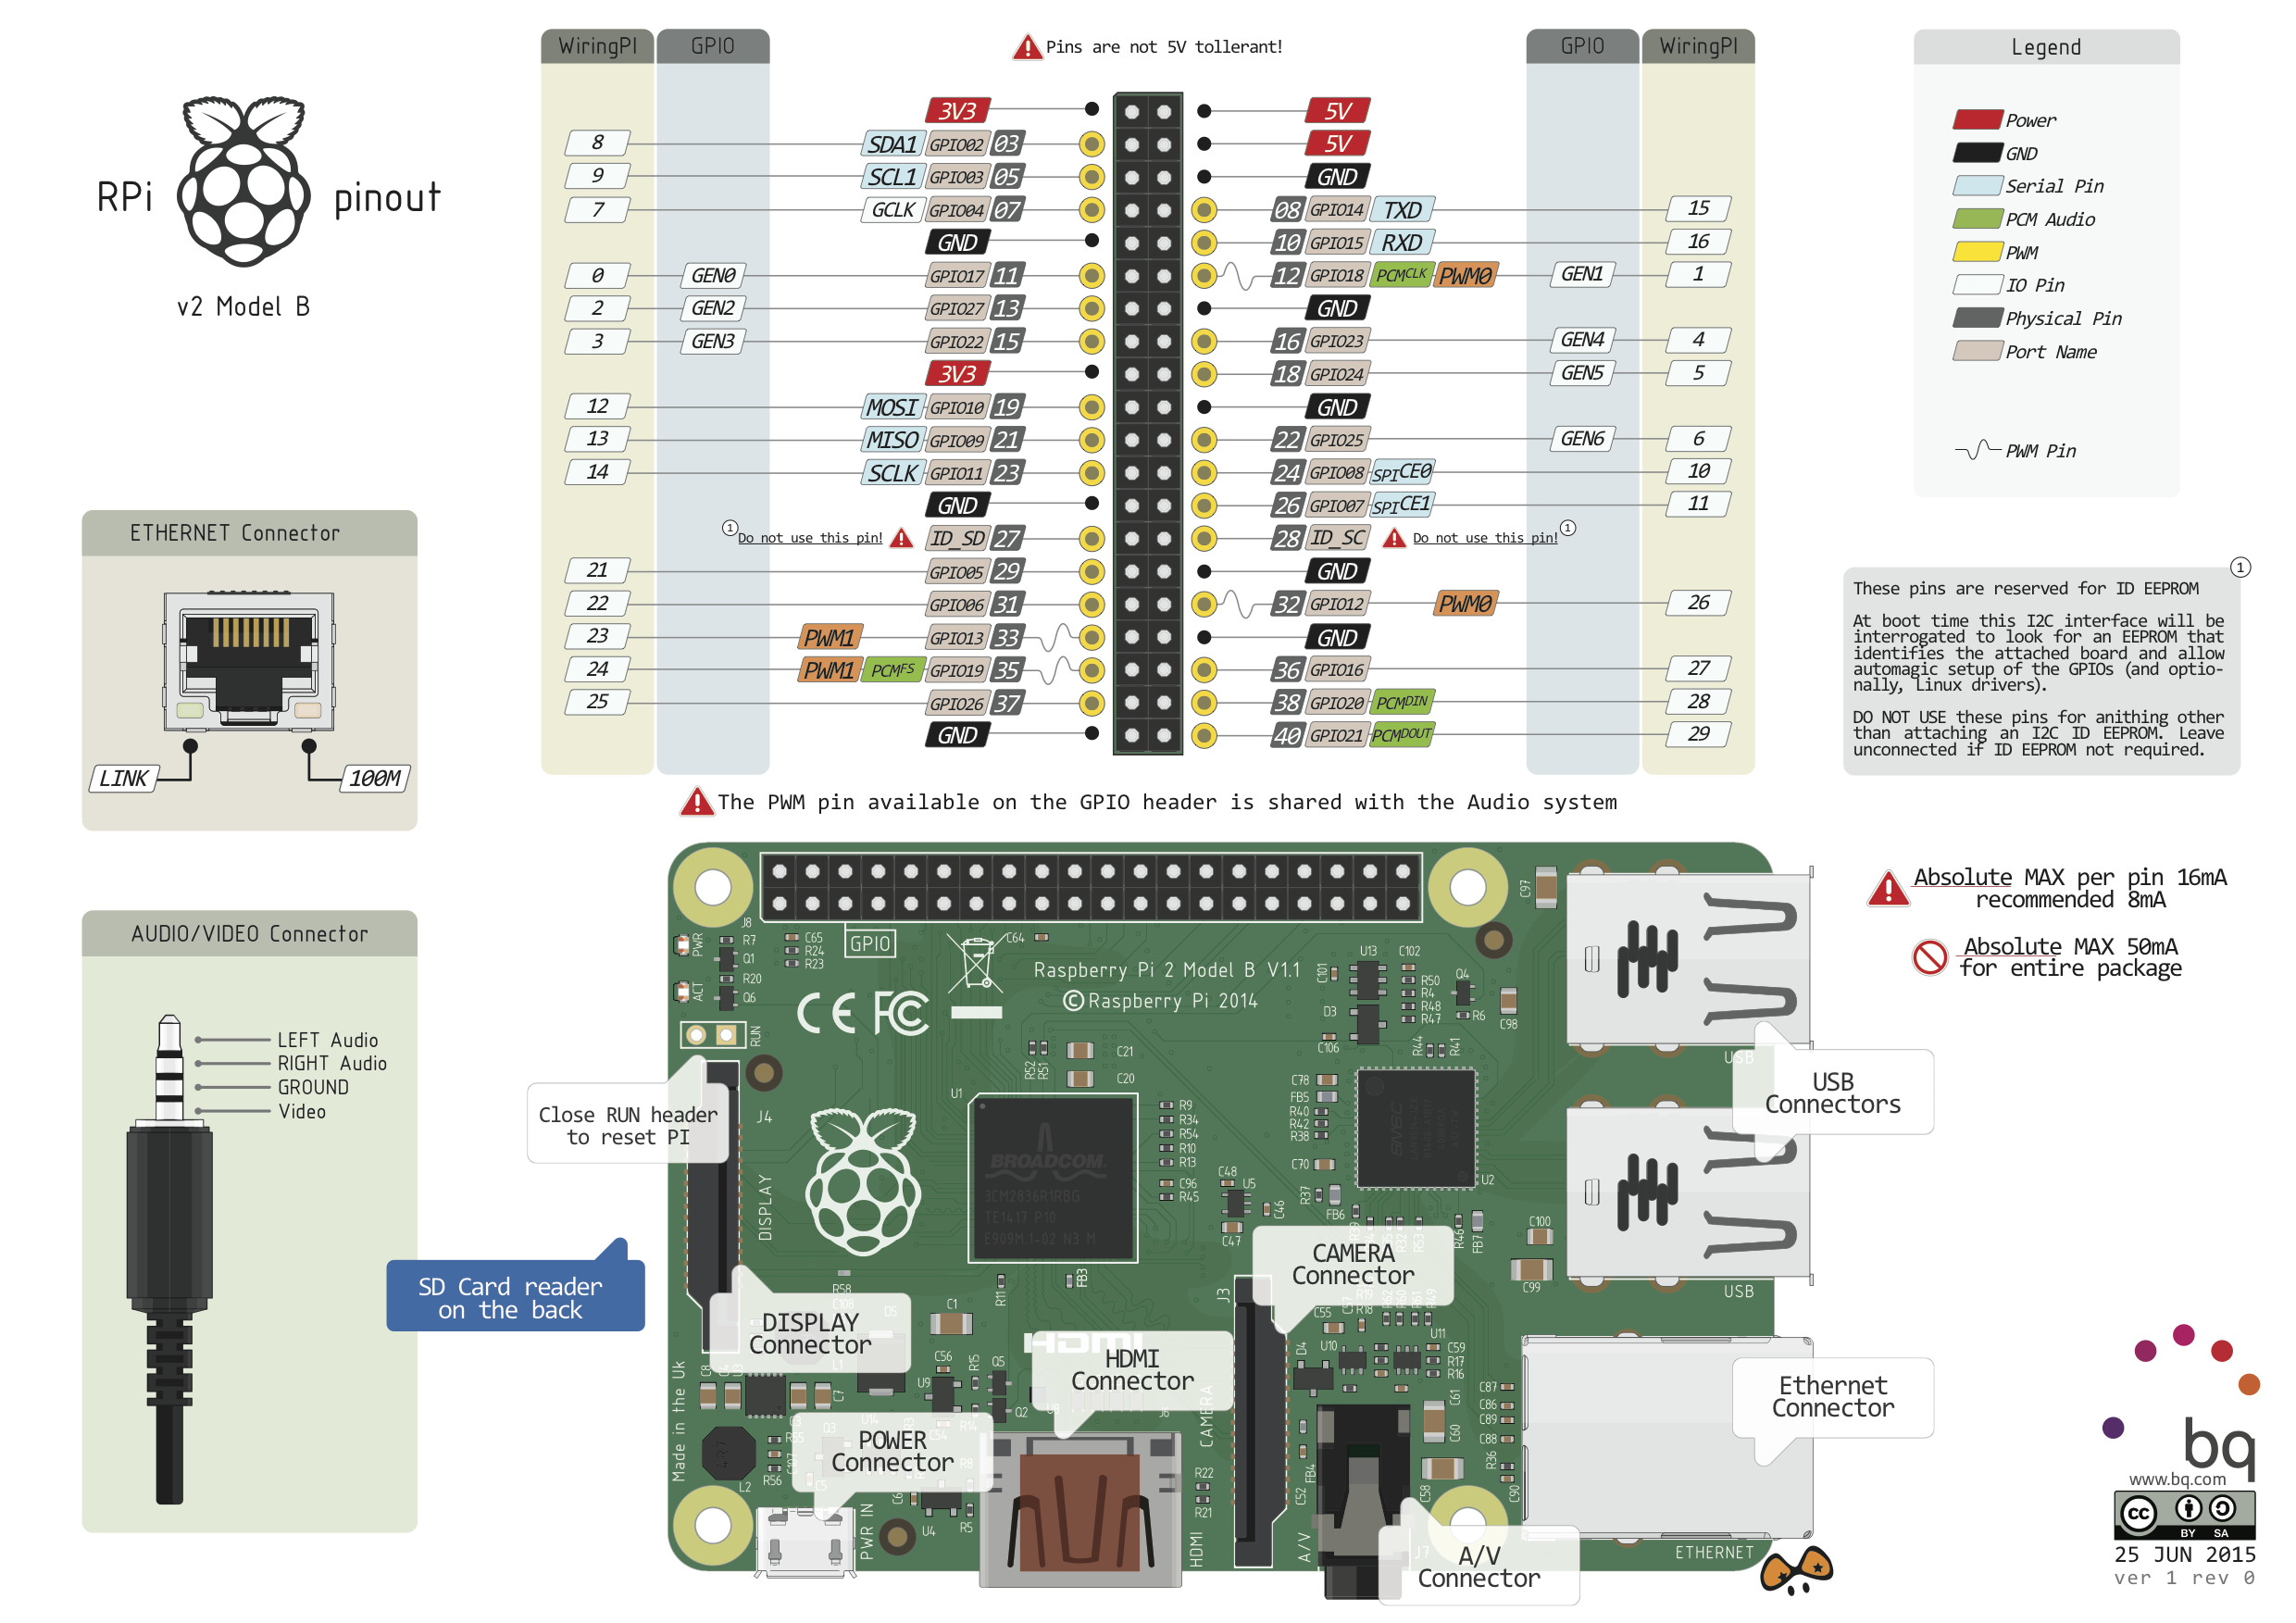

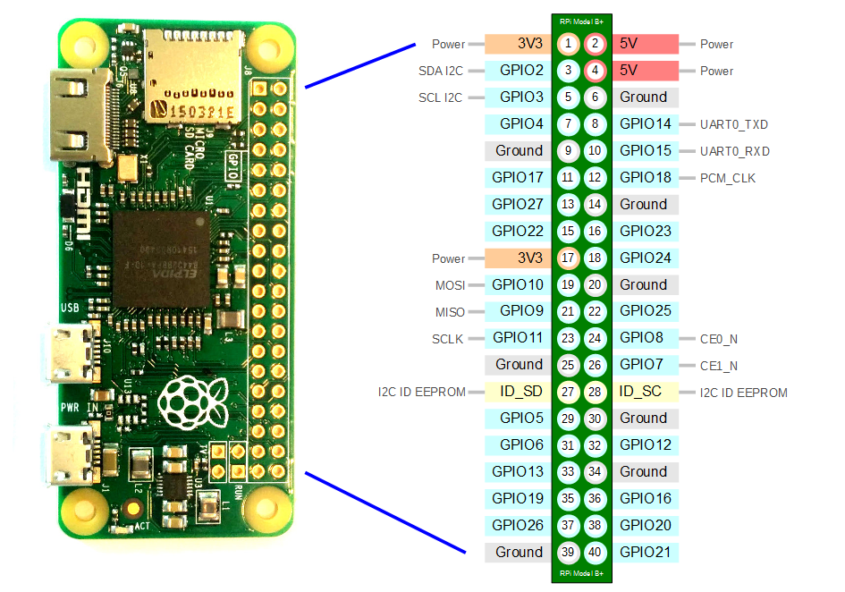

TELEMETRY BOARD:

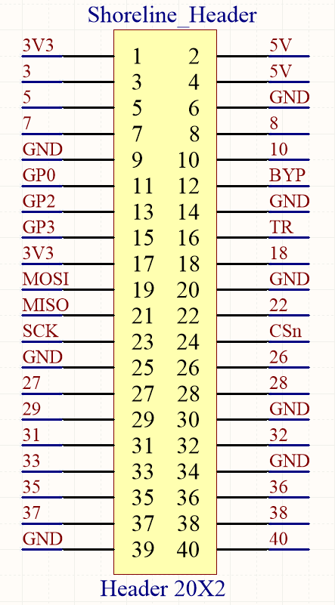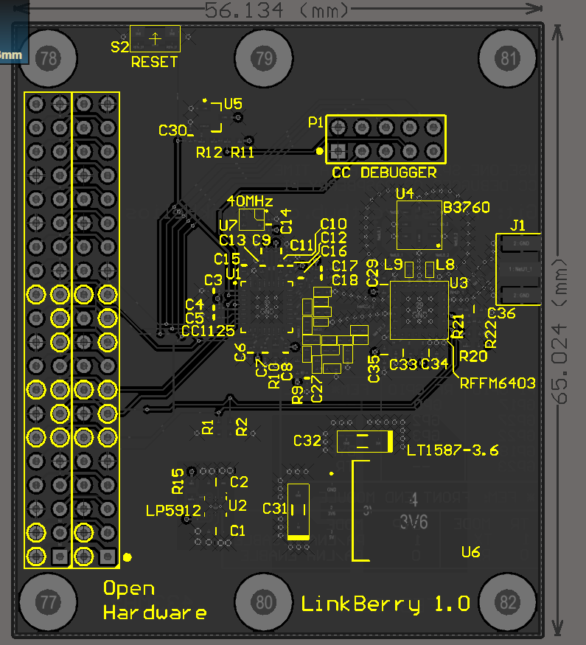

# Bidirectional SPI communication needs to be established between the Pi and the Telemetry board

# Encircled pins are used by the telemetry board

# Rotate any one diagram by 180deg

# Pins 19, 21, 23, 24 are used for SPI communication between the Pi and the RF IC (CC1125, TI)

# Pins 11, 13, 15 are GPIO pins of the CC1125 (read CC1125 documentation for their usage)

# Pins 12, 16 are control pins of the front-end module (RFFM6403)

|  |  |  |  |
| --- | --- | --- | --- |
| **Header Pin No.** | **Pi GPIO** | **CC1125 GPIO** | **RFFM6403 CTRL** |
| 11 | GP17 | GP0 | ----- |
| 13 | GP27 | GP2 | ----- |
| 15 | GP22 | GP3 | ----- |
| 12 | GP18 | ----- | BYP |
| 16 | GP23 | ----- | TR |

|  |  |
| --- | --- |
| **TR** | **MODE** |
| 1 | TX |
| 0 | RX |

|  |  |
| --- | --- |
| **BYP** | **MODE** |
| 1 | PA/LNA Disable |
| 0 | PA/LNA Enable |

GSM BOARD:

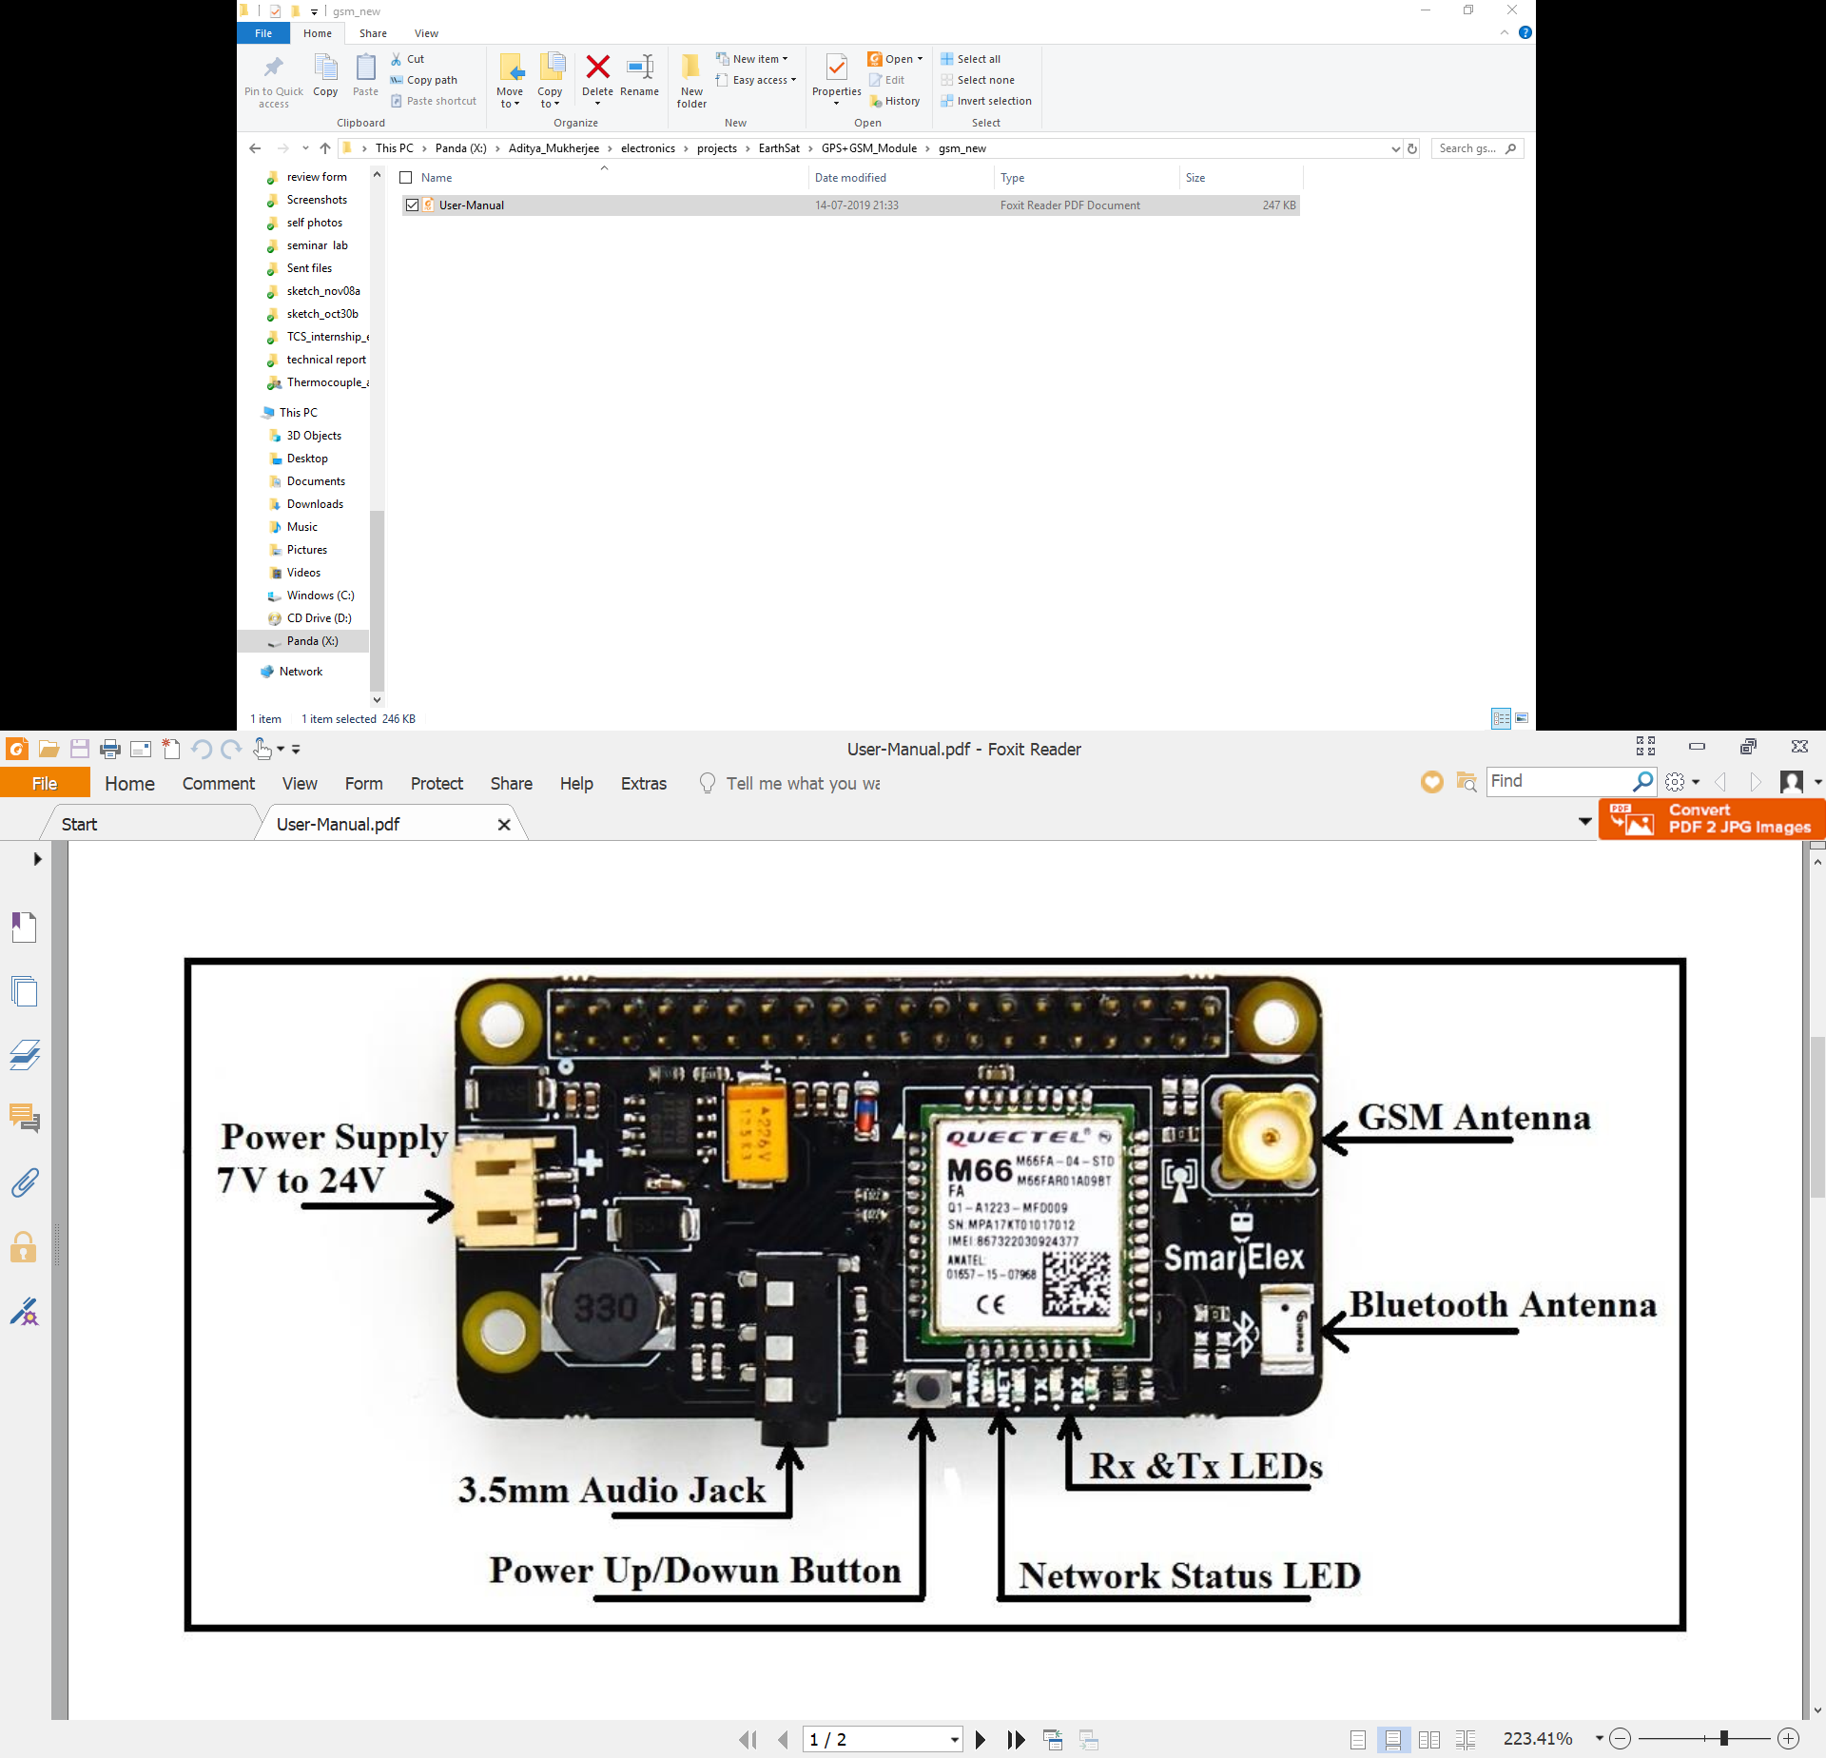

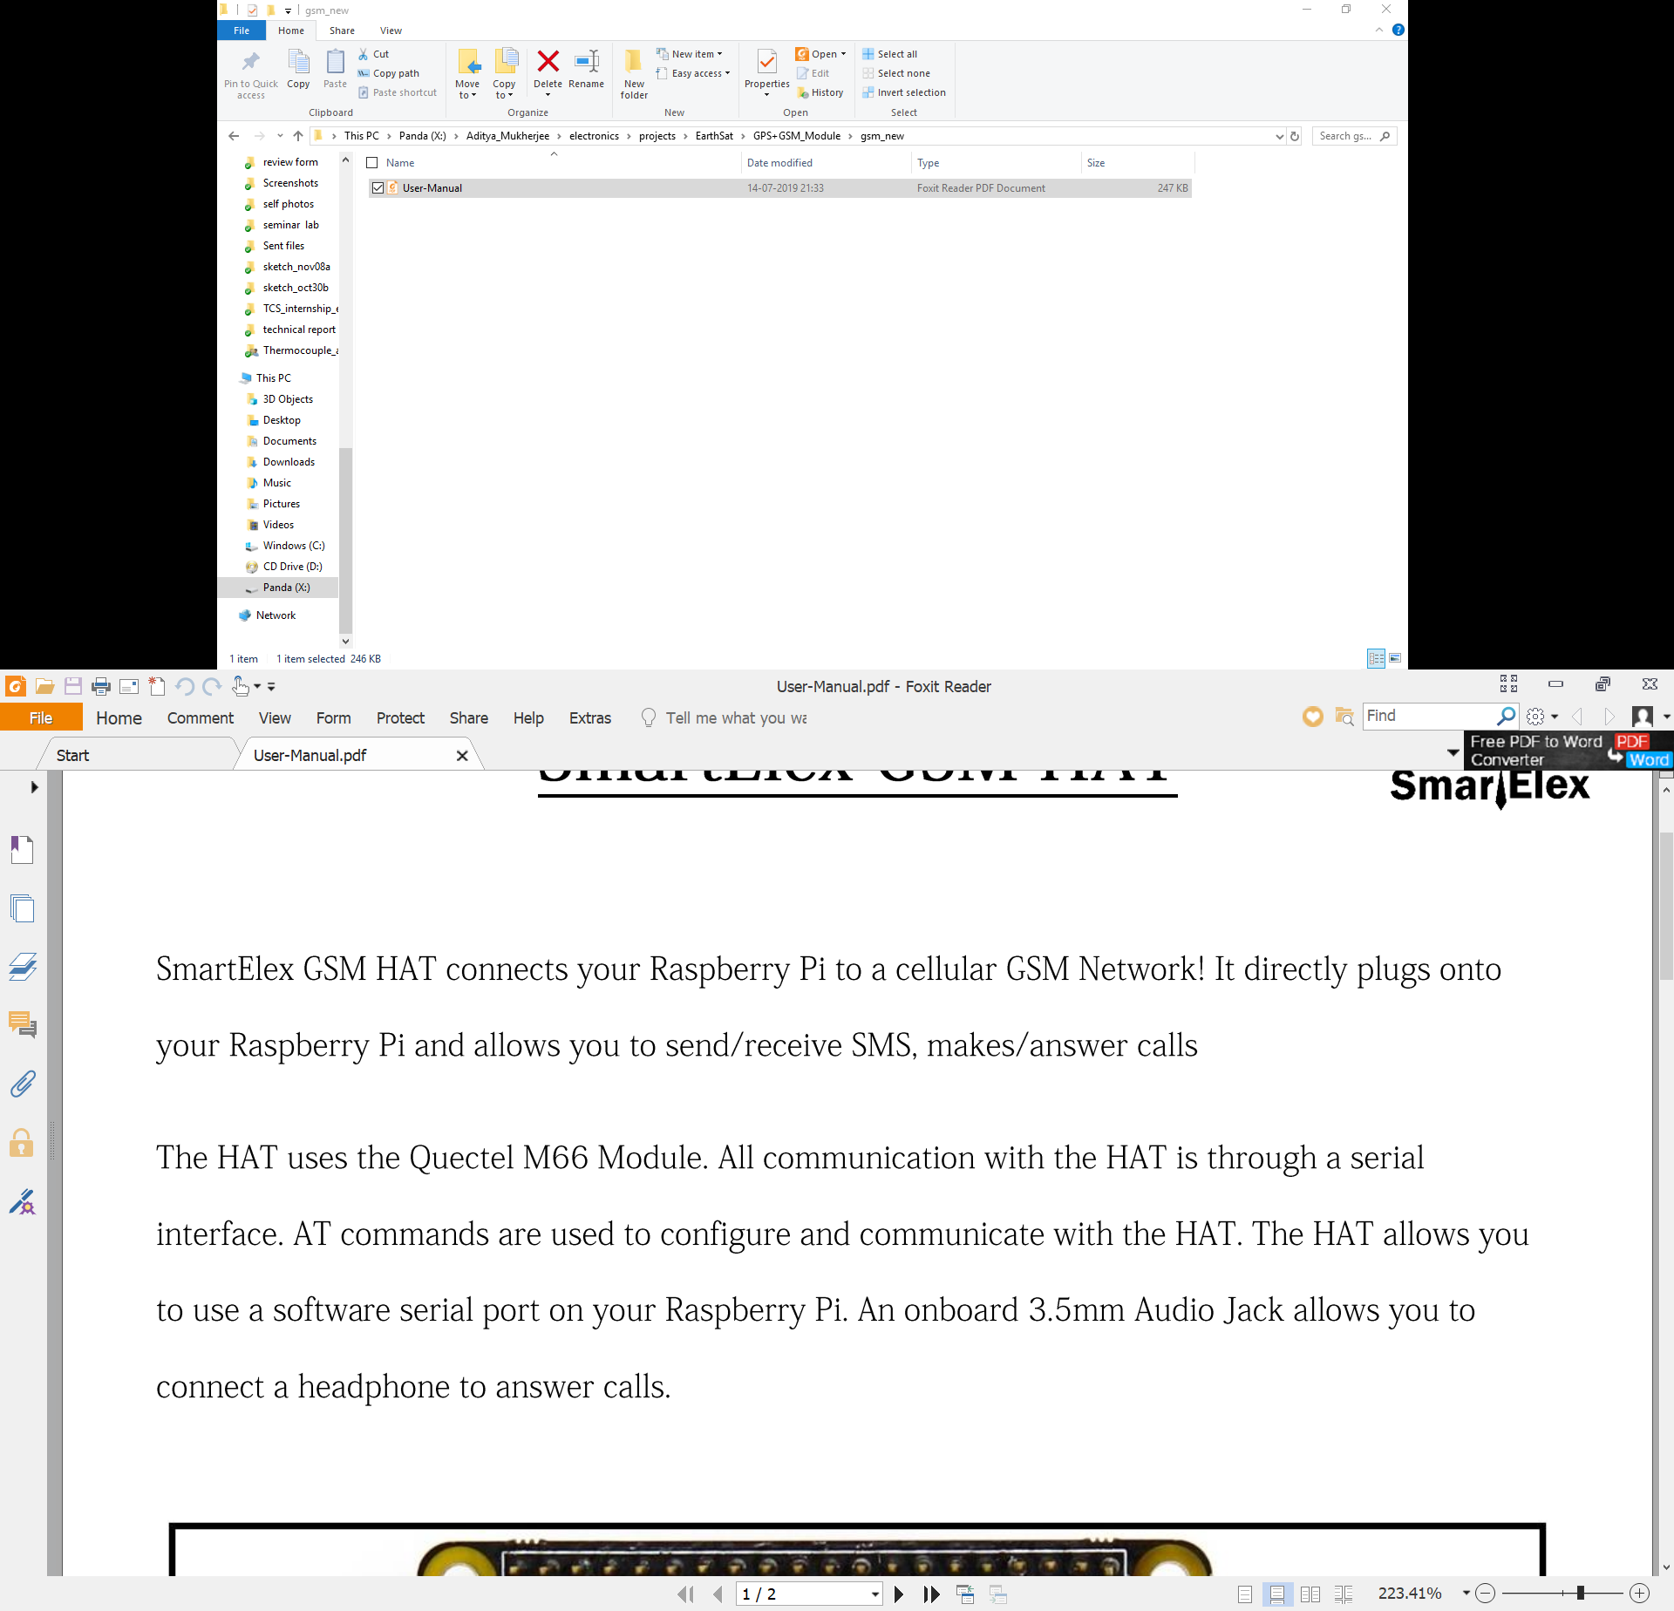

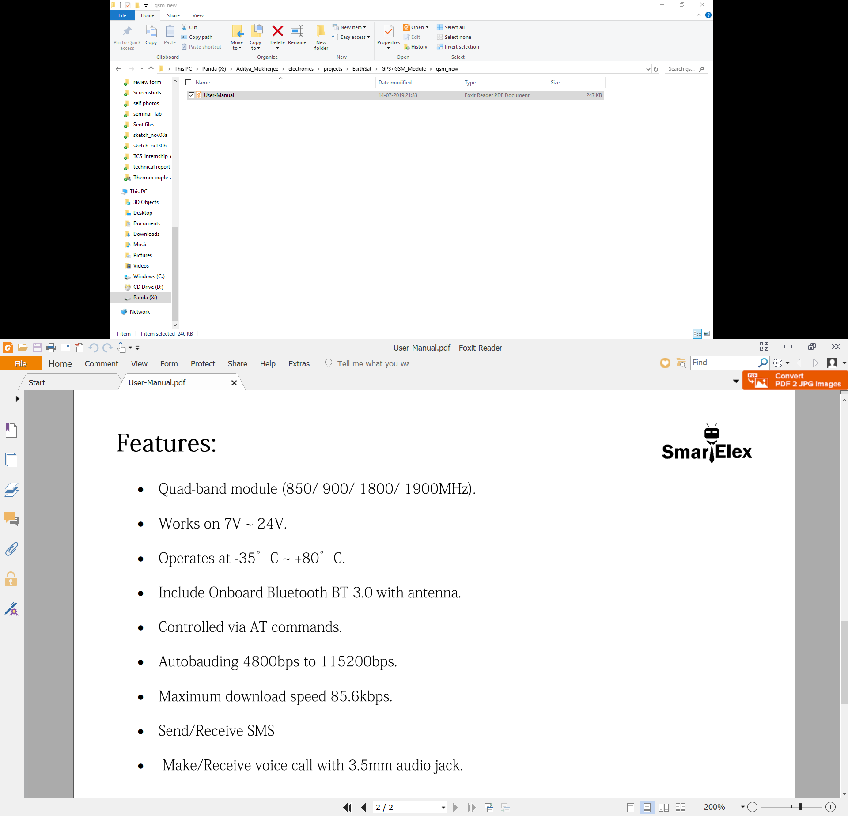

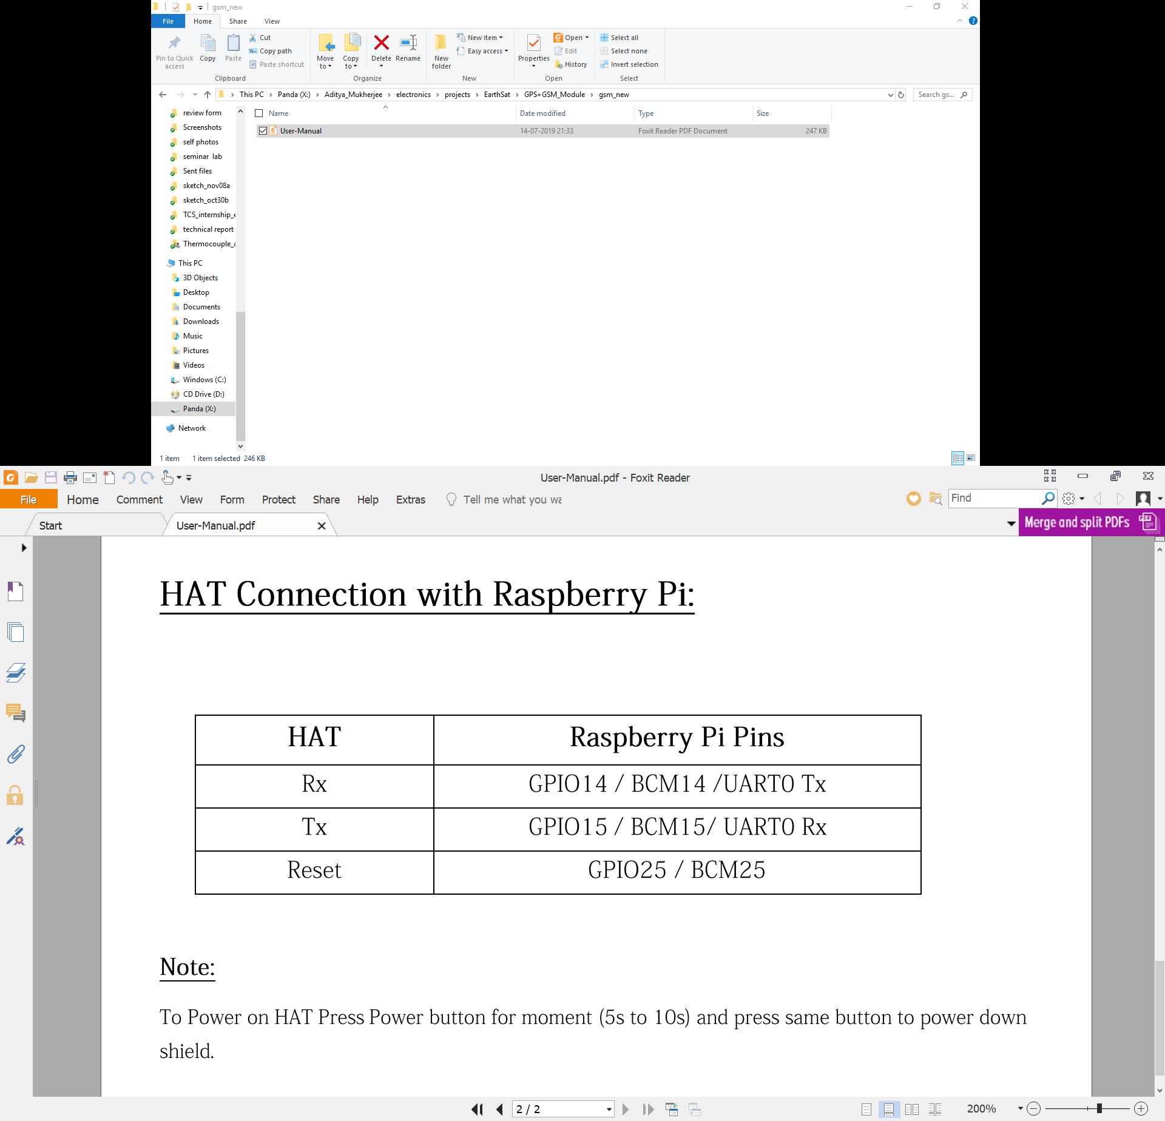

GPS BOARD:

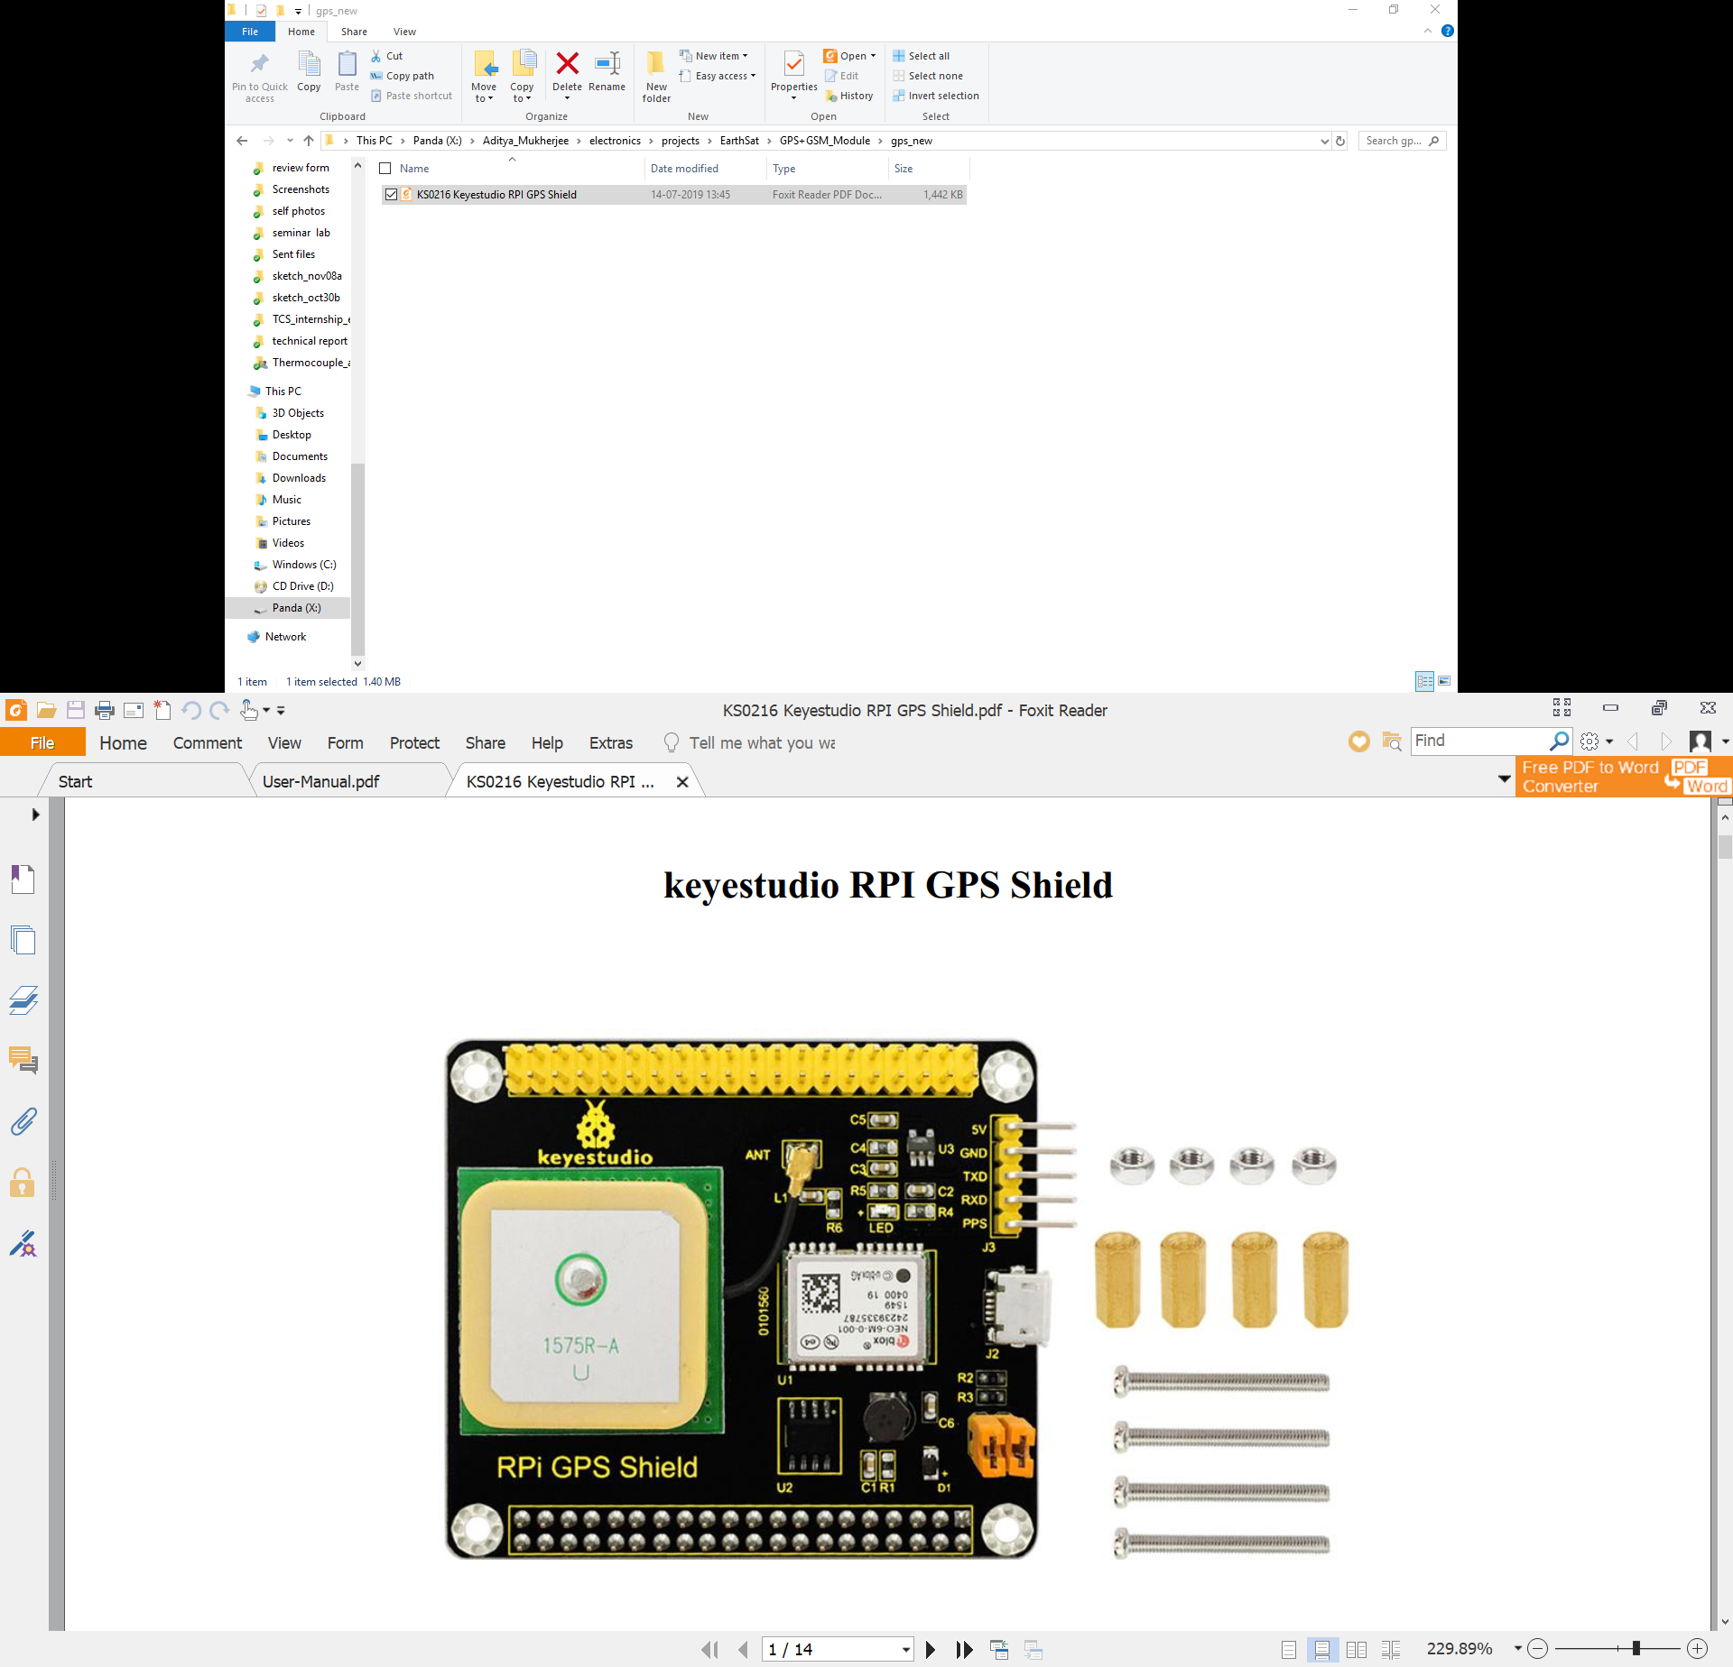

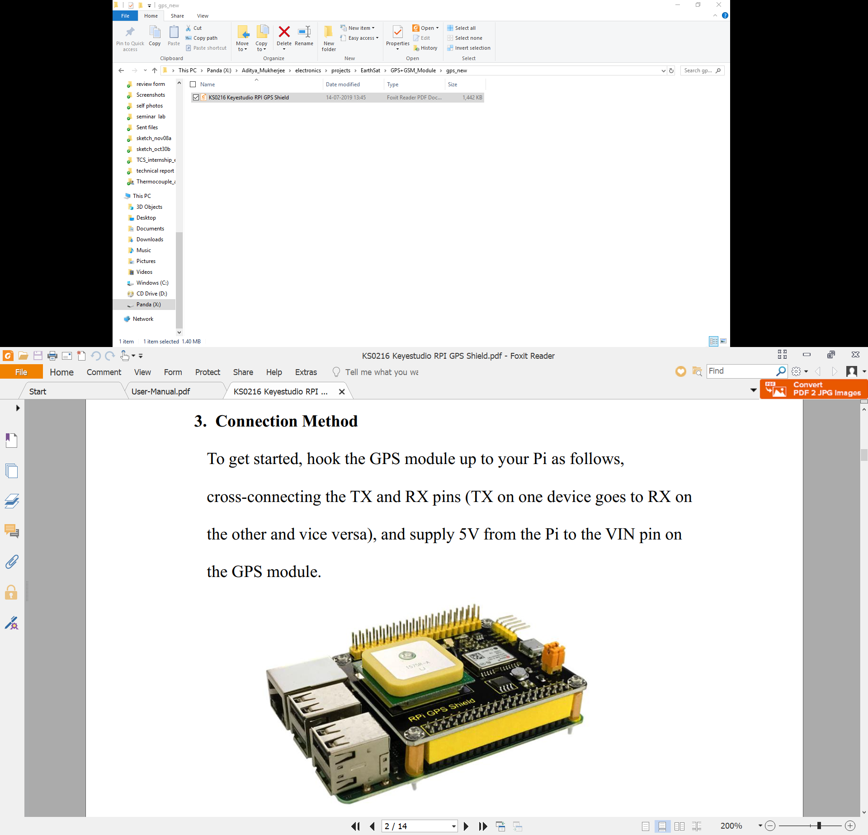

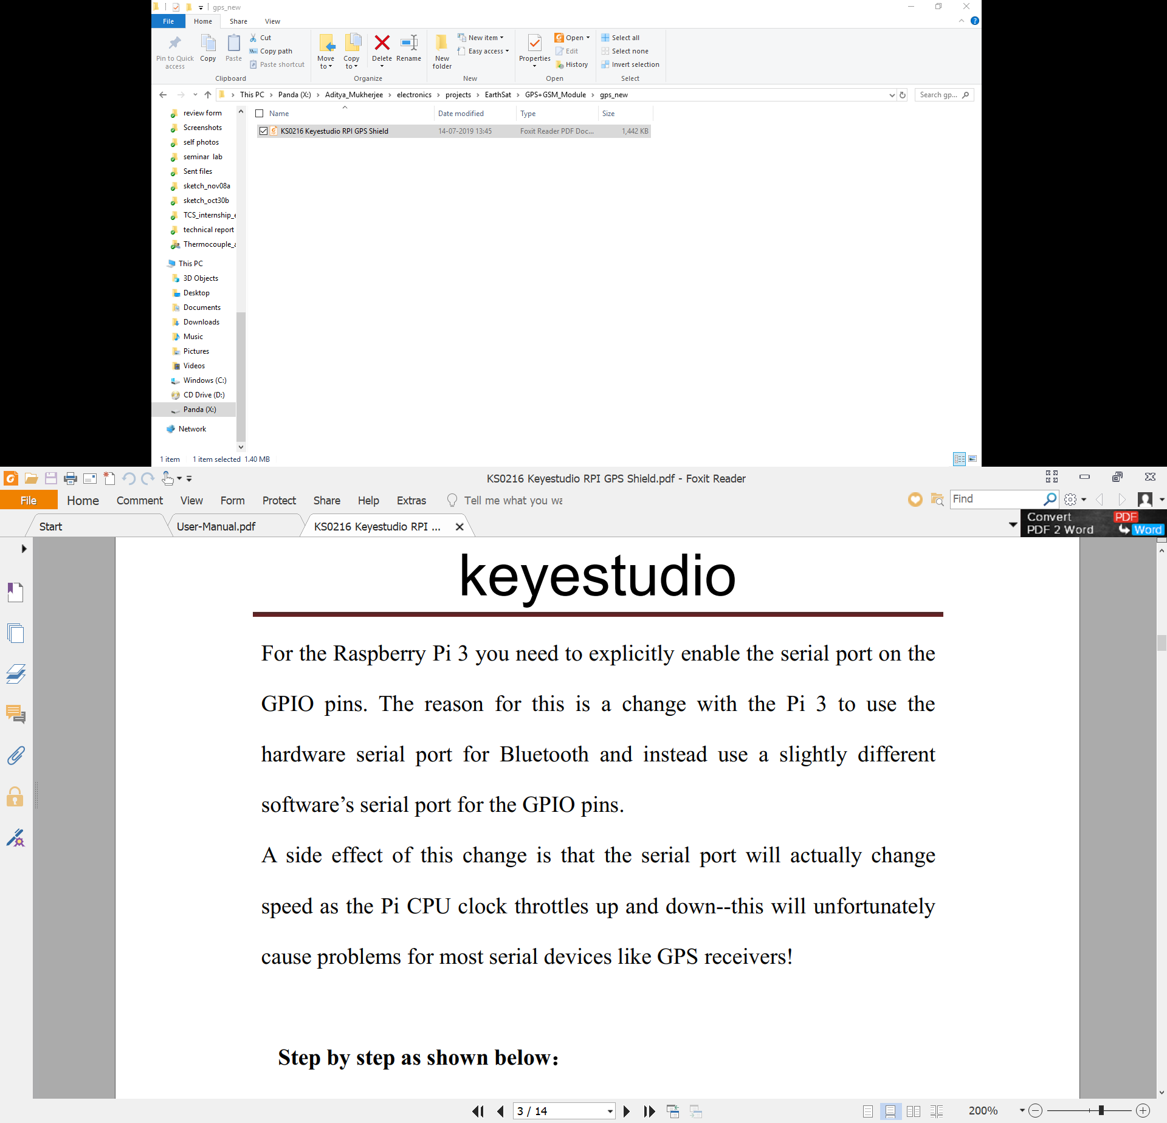

**# NOTE: GPS and GSM boards use the same two pins for serial communication so, we need to mux and demux the RX and TX pins.**

**# The GPIO pins for the mux and demux shall be updated once designed**

**# Information about the sensor board shall also be updated once it is designed, for now reserve the I2C bus for the sensors.**

**# SPI communication between the telemetry board and Pi will also be required at the ground station.**